## **Steps to Configure Visual Studio for UI Code**

1. Follow the below procedures to run Angular application in Visual Studio:

Required Software:

* NODE 6.11.0.
* NPM 3.10.10.
* Visual Studio Code (2010)
* SVN Code Rep. access and tortoise SVN (IBEMS Angular Application)

Note: If required software not present please raise an IT request.

1. Once above points are done, then execute the below commands in Visual Studio Management (VSM) CMD one by one

* npm config set strict-ssl false
* npm config set proxy http://10.9.64.4:8002
* npm config set http-proxy http://10.9.64.4:8002
* npm config set https-proxy http:// 10.9.64.4:8002

Note : 10.9.64.4:8002 This Ip address is the Global address of L&T Services Bangalore. below image is for getting the proxy IP address

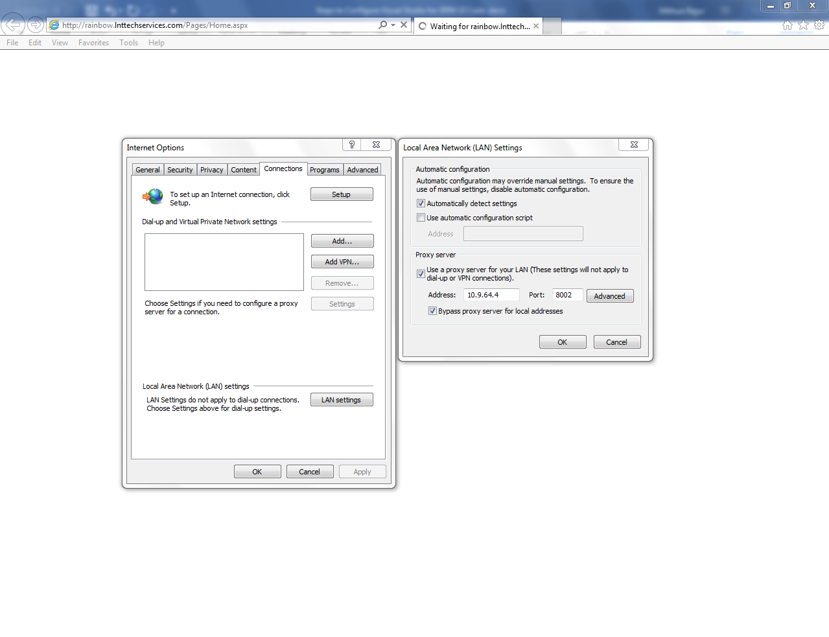

c. Run the below commands in Visual Studio console:

* npm install (to install dependency)
* npm install -g @angular/cli@1.1.2
* Set Environmental Variable (C:\Users\20113210\AppData\Roaming\npm) in PATH
* ng serve (to run iBems Angular Application)
* check with this URL in the browser <http://localhost:4200>
* If issues in logging, change the ip address in the file **D:\angularUI\src\assets\StaticJSONService\envSetup.json file** to your system ip and port in which ibems-server is running.

Note : Without PATH setting, ng command won’t start in the System

Below image is showing the Set Environmental Variable in PATH

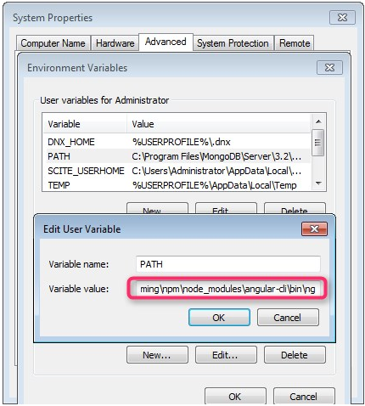

TEST in Your visual studio management Before Start Angular Application

Main Commands to test the Environment:

1. node -v
2. npm -v
3. ng -v
4. ng serve (after this command application is launch successfully)

